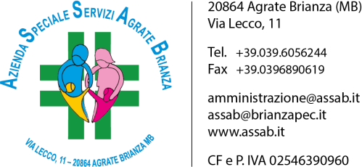

REPORT SPESE CONDOMINIALI
ANNO | in capo ad Assab | in capo ai condomini | Totale
2014 | 55.121 € | 86.045 € | 141.166 €
2015 | 52.171 € | 83.058 € | 135.229 €
2016 | 48.977 € | 80.829 € | 129.806 €
2017 | 38.221 € | 72.443 € | 110.664 €
2018 | 40.806 € | 74.889 € | 115.695 €
2019 | 50.655 € | 77.696 € | 128.351 €
2020 | 27.530 € | 62.306 € | 89.836 €

A.S.S.A.B. - Via Lecco, 11 – 20864 Agrate Brianza (MB)
Tel +39.0396056244 – Fax +39.0396890619 – CF e P. IVA 02546390960
amministrazione@assab.it – assab@brianzapec.it – www.assab.it

