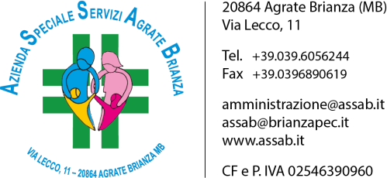

REPORT INCASSO AFFITTI
ANNO | IMPORTO
2014 | 205.992 €
2015 | 204.020 €
2016 | 202.651 €
2017 | 202.878 €
2018 | 204.331 €
2019 | 217.370 €
2020 | 220.423 €

A.S.S.A.B. - Via Lecco, 11 – 20864 Agrate Brianza (MB)
Tel +39.0396056244 – Fax +39.0396890619 – CF e P. IVA 02546390960
amministrazione@assab.it – assab@brianzapec.it – www.assab.it

